1. Finding AEM instance version that is currently running.

<http://localhost:4502/system/console/status-productinfo>

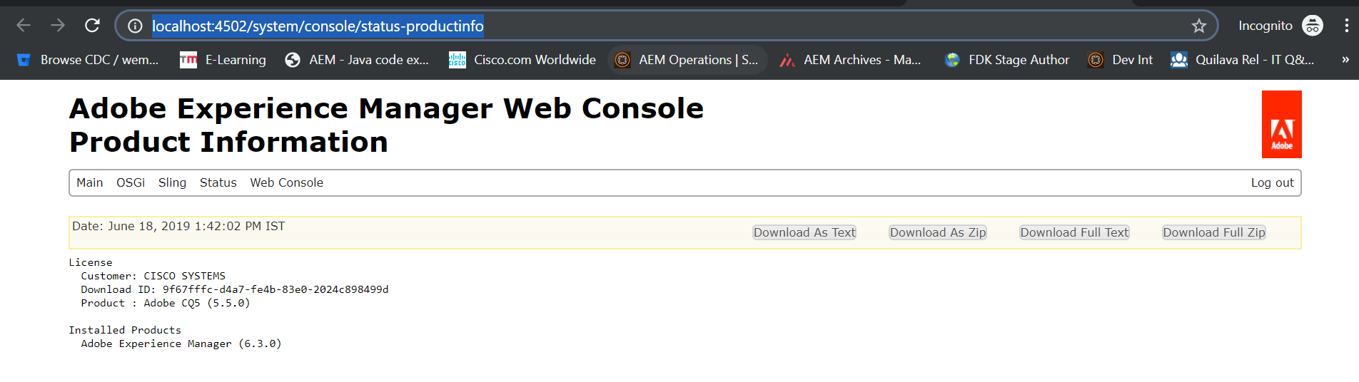

1. I18n translator console

<http://localhost:4502/libs/cq/i18n/translator.html>

